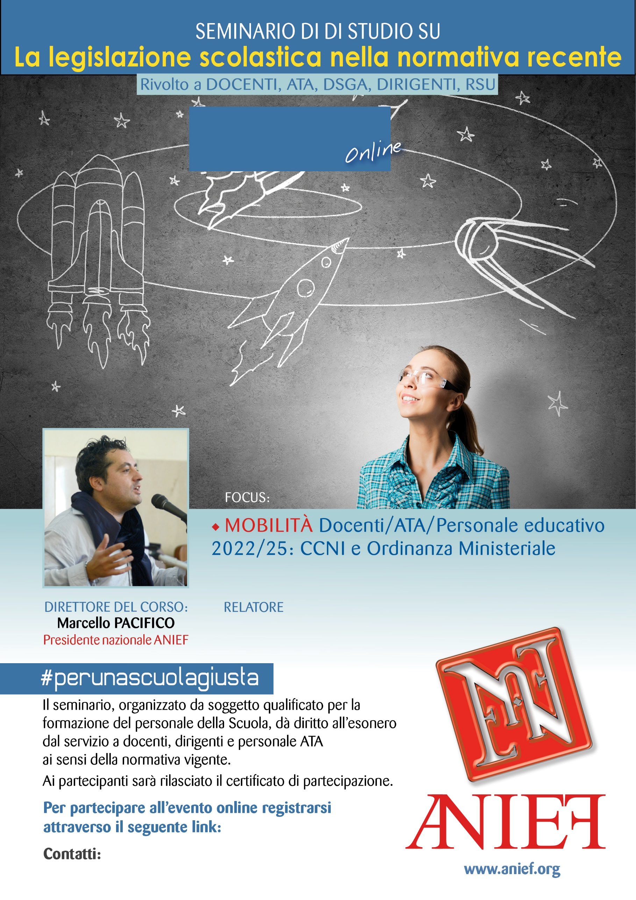

LINK DIRETTA: https://anief.org/as/8SFX

vibo-valentia@anief.net

MARIA DANIELA MAUCERI

CALABRIA - VIBO VALENTIA

08/03/2022 ORE 08:00 – 10:00